Assignment for Continuous Random Variables
- Consider the figure given below. Find the value c that makes the function f(x) a valid continuous probability distribution.
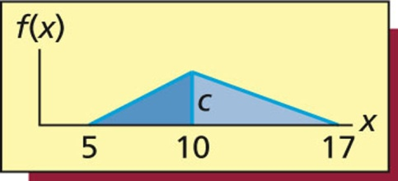
Solution:
f(x) is a valid continuous probability distribution, then for any value of x, f(x)≥0, and the total area under the furve f(x) is equal to 1.
That is: 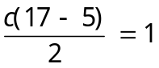, gives 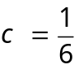
- The amount of sales tax paid on a purchase is rounded to the nearest cent. Assume that the round-off is uniformly distributed in the interval cent.
- Write the formula for the probability curve describing the round-off error.
- Graph the probability curve describing the round-off error.
- What is the probability that the round-off error exceeds .3 cent or is less than cent?
- Find the mean and the standard deviation of the round-off error.
- Find the probability that the round-off error will be within one standard deviation of the mean.

Solution:
- Let x be the random variable of round-off error.
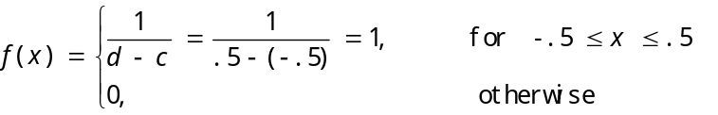
b.
f(x)
1

–.5 .5 cents
c. P({x > .3} {x < –.3}) = .2 + .2 = .4
d. 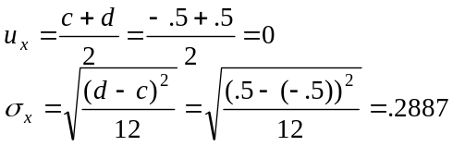
e. 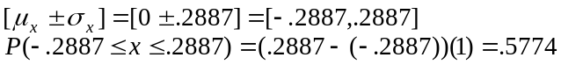
- Suppose the times required for a cable company to fix cable problems in its customers’ home are uniformly distributed between 10 minutes and 25 minutes.
- What is the probability that a randomly selected cable repair visit will take at least 15 minutes?
- What is the probability that a cable repair visit will take over 20 minutes given that it takes over 15 minutes?
Solution:
a.Let x be the amount of time that a randomly selected cable repair visit will take.
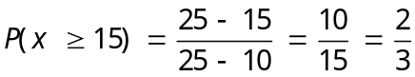
b.The conditional probability that a cable repair visit will take over 20 minutes given that it takes over 15 minutes is

- Let x be a normally distributed random variable having mean and standard deviation .
  - Find the z value for each of the following observed values of x and explain what the z value tells us about how the observed value of x compares to the mean, .
- 1100
- 800
  - What is the value of x that has a z value of 0.0? (You should be able to figure this out without doing any calculations.)
Solution:
a.[1]
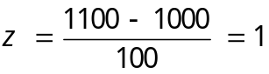;
The z value of 1 indicates that x is one standard deviation above the mean.
a.[2]
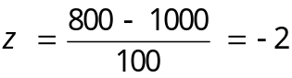;
The z value of -2 indicates that x is two standard deviations below the mean.

- If x= , z value is 0. So the desired value of x is 1000.
- Suppose that the random variable z has a standard normal distribution.
- Sketch and find each of the following probabilities using the normal table.
- P(z ≥ –1)
- P(–2.5 ≤ z ≤ .5)
- Sketch each of the following z values, and use the normal table to find each z value.
Solution:
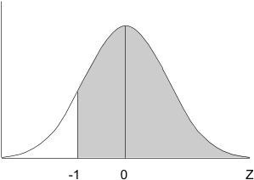
a.[1]

P(z ≥ –1) = P(z ≤ 1) =.8413
a.[2]
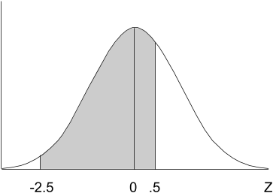

P(–2.5 ≤ z ≤ .5) = P( z ≤ .5) – P(z ≤ –2.5)= P( z ≤ .5) – (1– P(z ≤ 2.5))=.5199 – (1– .9938) = .5137
b.[1]
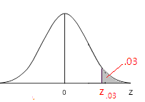
b.[2]

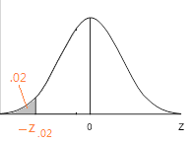

- An investment broker reports that the yearly returns on common stocks are approximately normally distributed with a mean return of 12.4 percent and a standard deviation of 20.6 percent.
  - Find the probability that a randomly selected
- Common stock will give a positive yearly return.
- Common stock will give more than a 10 percent return.
- Common stock will give a loss of at least 10 percent.
  - What percent of yearly returns are at or below the 10th percentile of the distribution of yearly returns? What percentage are at or above the 10th percentile? Find the 10th percentile of the distribution of yearly returns.
Solution:
Let x be the yearly return on a randomly selected common stock.
Given μ = 12.4, σ = 20.6
a.[1] P(x > 0) = P(z > )= P(z > –.60) =P(z < .60) = .7257
a.[2] P(x > 10) = P(z > –.12) = .5478
a.[3] P(x ≤ –10) = P(z ≤ –1.09) = 1– P(z ≤ 1.09)=1–.8621 = .1379
b. According to the definition of percentile, we know that 10 percent of yearly returns are at or below the 10th percentile of the distribution of yearly returns; 90 percent are at or above the 10th percentile.
Let k be the 10th percentile of the distribution of yearly returns.
Then P(x ≤ k) = 0.1 i.e. 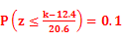 which gives (k–12.4)/20.6= –1.28, thus k=-13.968.
- A tire company has developed a new type of steel-belted radial tire. Extensive testing indicates the population of mileages obtained by all tires of this new type is normally distributed with a mean of 40,000 miles and a standard deviation of 4,000 miles. The company wishes to offer a guarantee providing a discount on a new set of tires if the original tires purchased do not exceed the mileage stated in the guarantee. What should the guaranteed mileage be if the tire company desires that no more than 2 percent of the tires will fail to meet the guaranteed mileage?
Solution:
Let x be the mileage obtained by a randomly selected tire of this new type; k be the desired guaranteed mileage if the tire company desires that no more than 2 percent of the tires will fail to meet the guaranteed mileage. Hence, we must choose k such that
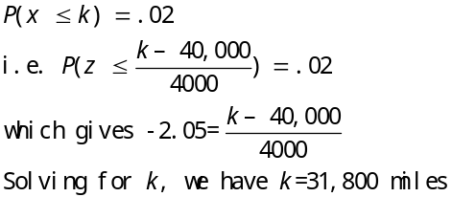
- In the movie Forrest Gump, the public school required an IQ of at least 80 for admittance.
  - If IQ test scores are normally distributed with mean 100 and standard deviation 16, what percentage of people would qualify for admittance to the school.
  - If the public school wishes 95 percent of all children to qualify for admittance, what minimum IQ test score should be required for admittance?
Solution:
Let x be the random variable of IQ test score.
- People having an IQ of at least 80 would qualify for admittance to the school.
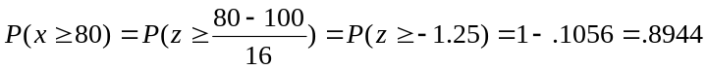
b. Let k be the minimum IQ test score required for admittance if the public school wishes 95 percent of all children to qualify for admittance. Here, we want 95 percent of all children to have scores greater than or equal to k. Hence, we must choose k such that
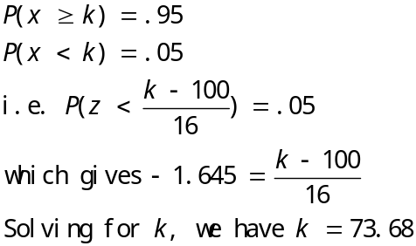

- Net interest margin-often referred to as spread-is the difference between the rate banks pay on deposits and the rate they charge for loans. Suppose that the net interest margins for all U.S. banks are normally distributed with a mean of 4.15 percent and a standard deviation of .5 percent.
  - Find the probability that a randomly selected U.S. bank will have a net interest margin that exceeds 5.40 percent.
  - Find the probability that a randomly selected U.S. bank will have a net interest margin less than 4.40 percent.
  - A bank wants its net interest margin to be less than the net interest margins of 15 percent of all U.S. banks. Where should the bank’s net interest margin be set?
Solution:
Let x be the net interest margin that a randomly selected U.S. bank will have.
a.
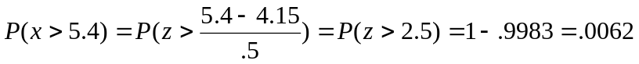
b.
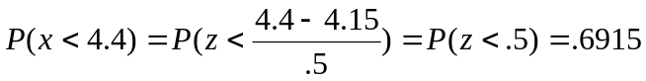
c. Let k be the bank’s net interest margin so that it will be less than the net interest margins of 15 percent of all U.S. banks. Here, we want 15 percent of all U.S. banks to have the net interest margins greater than k. Hence, we must choose k such that
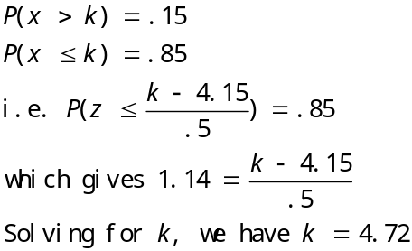

- In order to gain additional information about respondents, some marketing researchers have used ultraviolet ink to precode questionnaires that promise confidentiality to respondents. Of 205 randomly selected marketing researchers who participated in an actual survey, 117 said that they disapprove of this practice. Suppose that, before the survey was taken, a marketing manager claimed that at least 65 percent of all marketing researchers would disapprove of the practice.
- Assuming that the manager’s claim is correct:
  - Verify that we may use the normal approximation to the binomial.
  - Use the normal approximation to the binomial to calculate the probability that 117or fewer of 205 randomly selected marketing researchers would disapprove of the practice.
- Based on your result of part a[2], do you believe the marketing manager’s claim? Explain.
Solution:
Let x be the number of marketing researchers who would disapprove of the practice in a random sample of 205. x has a binomial distribution with .
a.[1] Since both np=133.25 and n(1 – p)=71.75 exceed 5, we may use the normal approximation to the binomial.
a.[2] x is approximately normal with parameters and
The probability that 117or fewer of 205 randomly selected marketing researchers would disapprove of the practice is approximated by the normal probability as follows
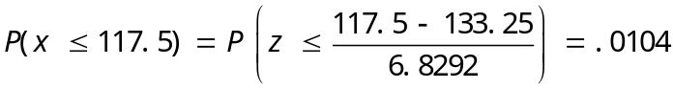
b.
Of 205 randomly selected marketing researchers who participated in an actual survey, 117 said that they disapprove of this practice. This is a rare event since the probability that 117or fewer of 205 randomly selected marketing researchers would disapprove of the practice is less than 0.05. Thus I don’t believe the marketing manager’s claim that at least 65 percent of all marketing researchers would disapprove of the practice.

- A motel accepts 325 reservations for 300 rooms on July 1, expecting 10 percent no-shows on average from past records. Use the normal approximation to the binomial to find the probability that all guests who arrive on July 1 will receive a room.
Solution:
Let x be the number of guests who arrive on July 1.
x is approximately normal with parameters and
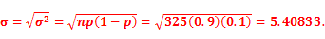
All guests who arrive on July 1 will receive a room implies that x is less than or equal to 300.
So the probability that all guests who arrive on July 1 will receive a room with continuity correction is
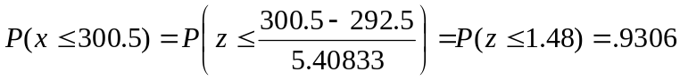
- Suppose we wish to justify the claim that fewer than 50 percent of adults in Germany have purchased blue jeans in the past three months. The survey reported by Giges found that 45 percent of 400 randomly selected respondents in Germany had purchased blue jeans in the past three months.
- Use the normal approximation to the binomial distribution to calculate the probability that 45 percent or fewer of 400 randomly selected German adults would have purchased blue jeans in the past three months.
- Based on the probability you computed in part a, would you conclude that fewer than 50 percent of adults in Germany have purchased blue jeans in the past three months.
Solution:
Let x be the number of German adults who had purchased blue jeans in the past three months in a random sample of 400 respondents.
- x is approximately normal with parameters and
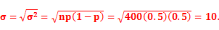
The probability that 45 percent (400*0.45=180) or fewer of 400 randomly selected German adults would have purchased blue jeans in the past three months with continuity correction is
b. It is found that 45 percent of 400 randomly selected respondents in Germany had purchased blue jeans in the past three months. This is a rare event since the probability that 45 percent (400*0.45=180) or fewer of 400 randomly selected German adults would have purchased blue jeans in the past three months is less than 0.05. Thus I don’t believe that at least 50 percent of adults in Germany have purchased blue jeans in the past three months. That is, we would conclude that fewer than 50 percent of adults in Germany have purchased blue jeans in the past three months.

